# Jenkins Backup Plugins

It is important to have a Jenkins backup with its data and configurations. It includes job configs, plugins, build logs, plugin configuration, etc.

Jenkins provides a backup plugin which can be used to get backup critical configuration settings related to Jenkins. Let's see how to configure backup plugin in Jenkins:

**Step 1:** Go to the Jenkins dashboard screen and click on **Manage Jenkins**.

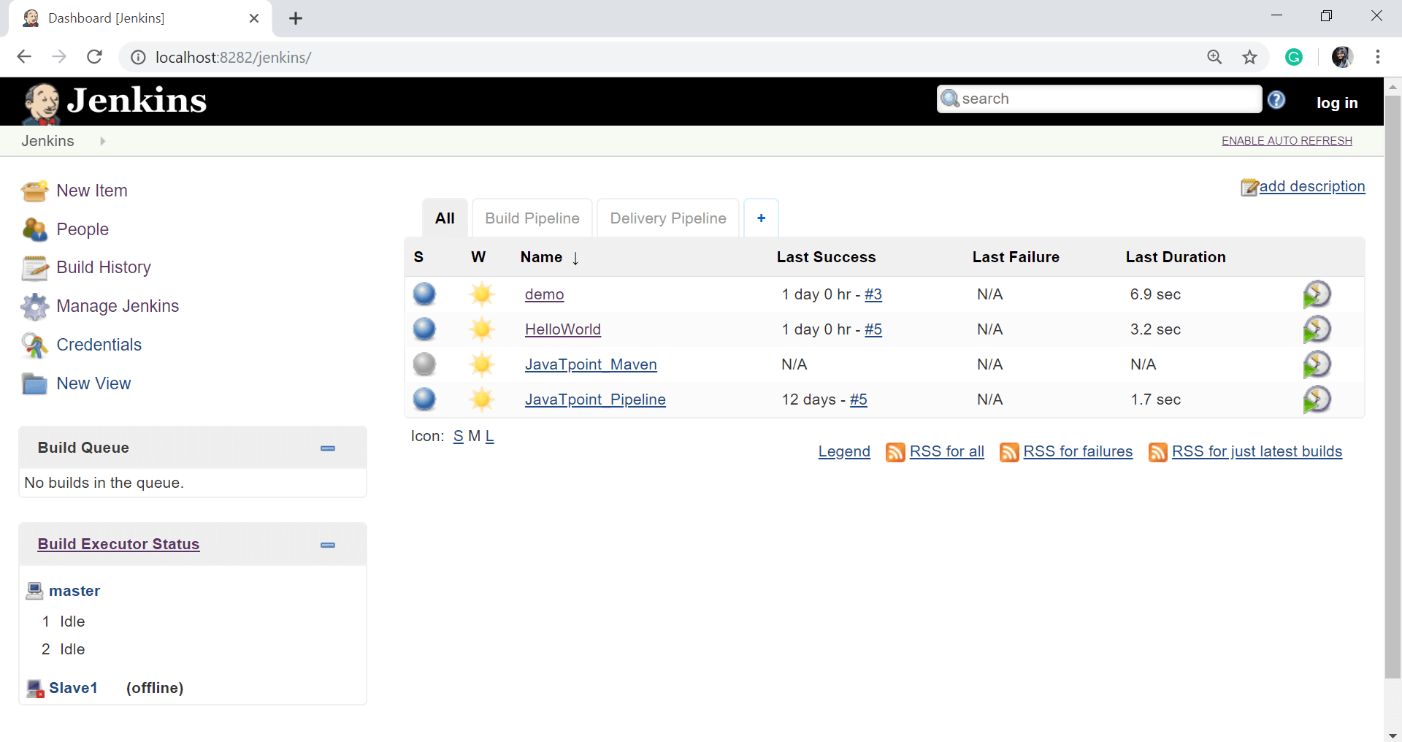

**Step 2:** Select **Manage Plugins**.

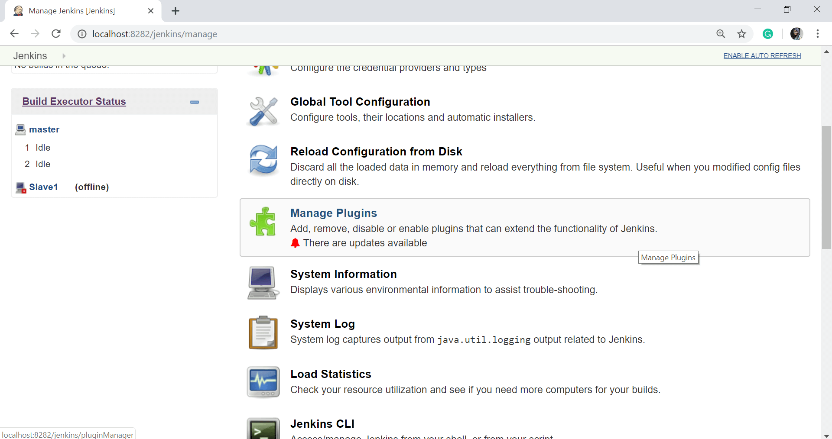

**Step 3:** Go to the Available tab and search for "**Backup**" plugin on the filter field.

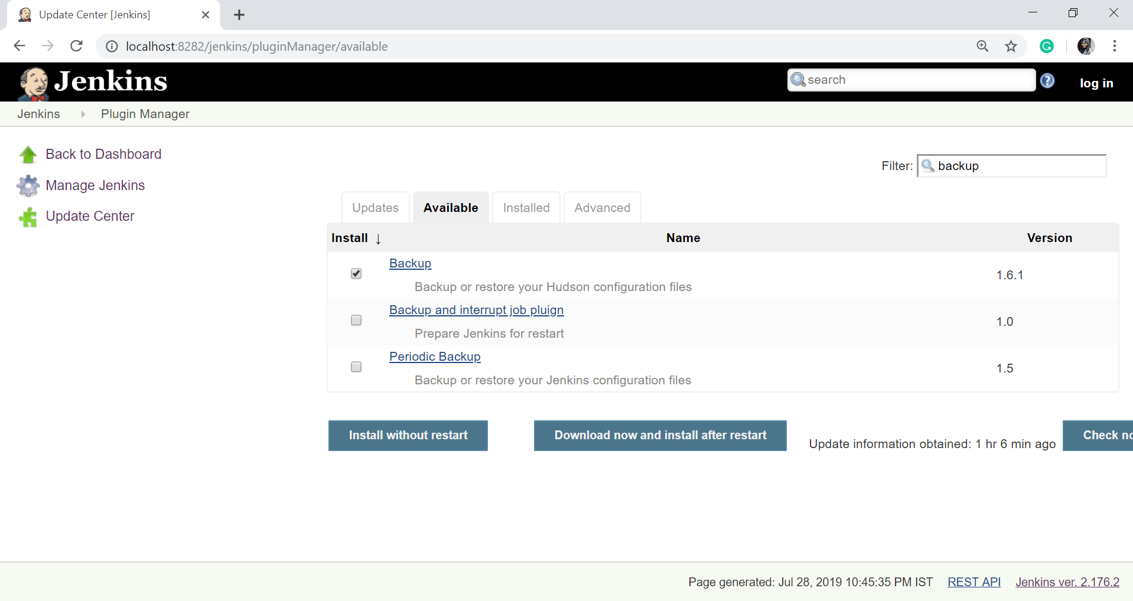

**Step 4:** After successful installation, click on **Go back to the top page** link.

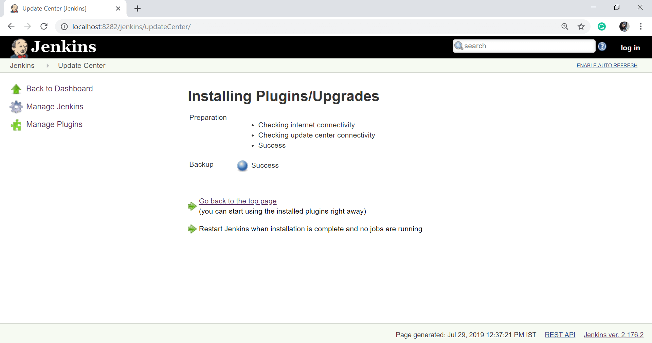

**Step 5:** Now, when you go to the **Manage Jenkins** option, and scroll down, you will see **Backup manager** as an option. Select this option.

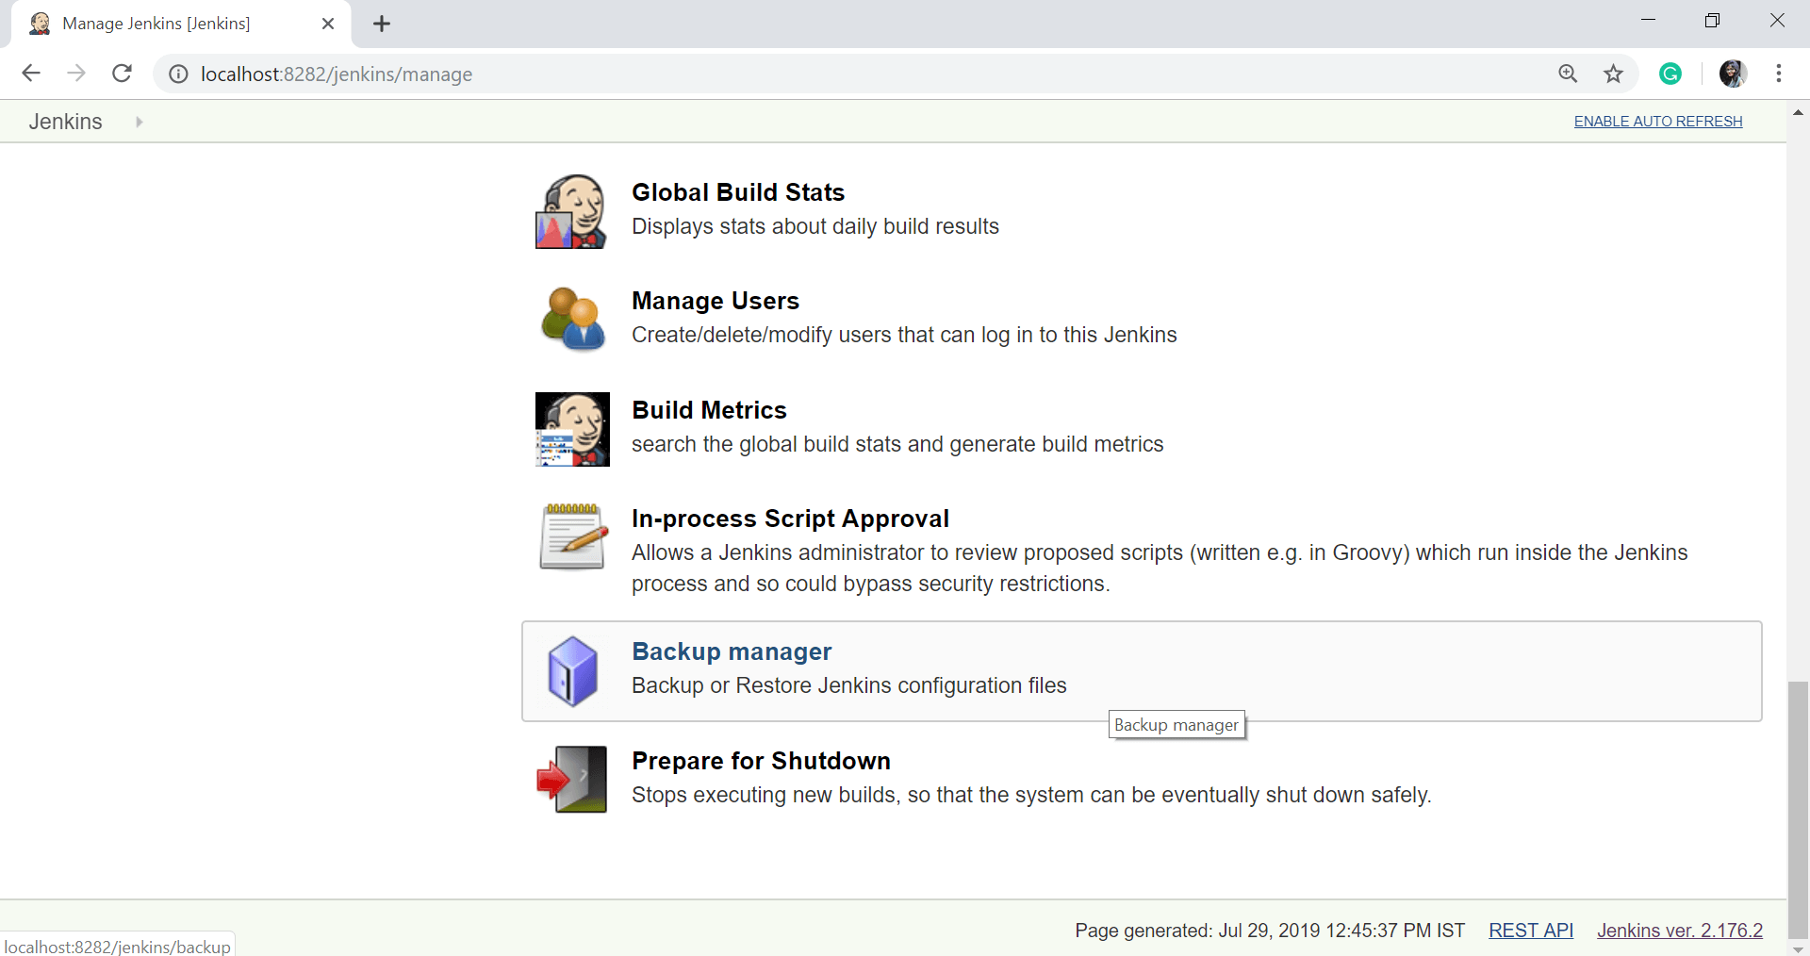

**Step 6:** Click on **setup**.

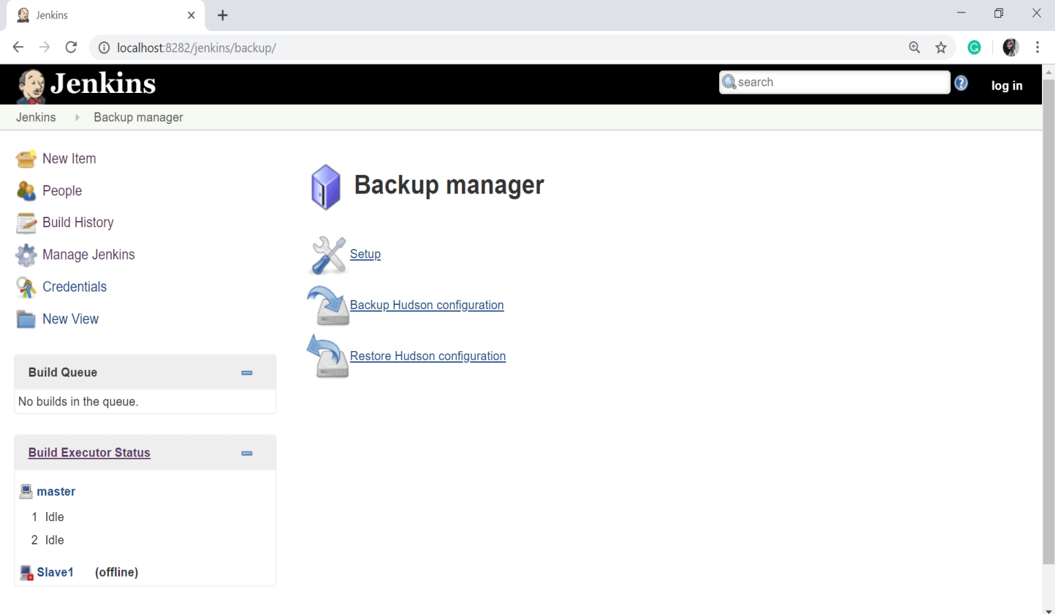

**Step 7:** Here, enter the directory name in the field of **Backup directory**. Please make sure that it is on another drive which is different from the drive where your Jenkins instance is installed. Then, click on the **Save** button.

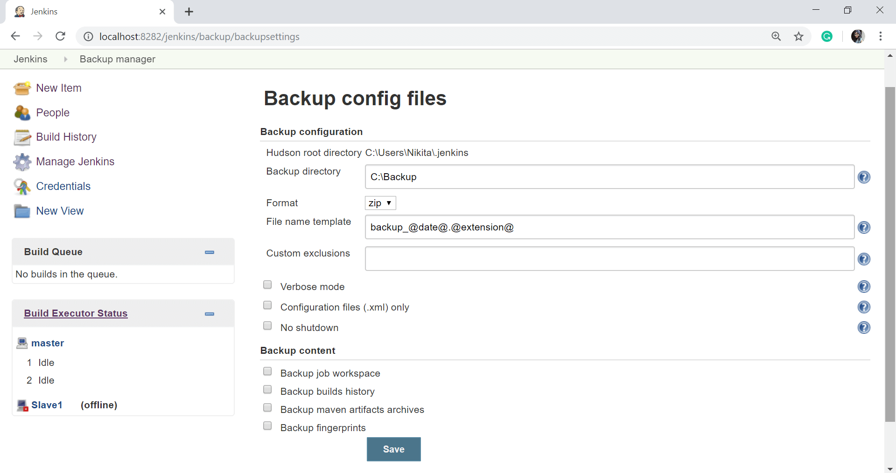

**Step 8:** Click on the **Backup Hudson configuration** link from the backup manager page to initiate the backup.

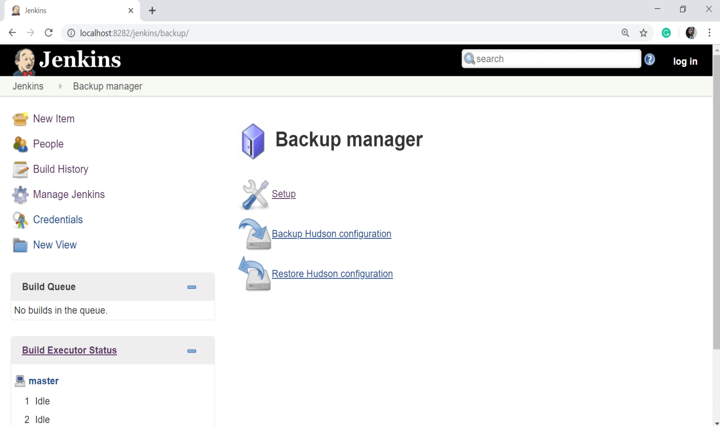

The next page will show the backup status.

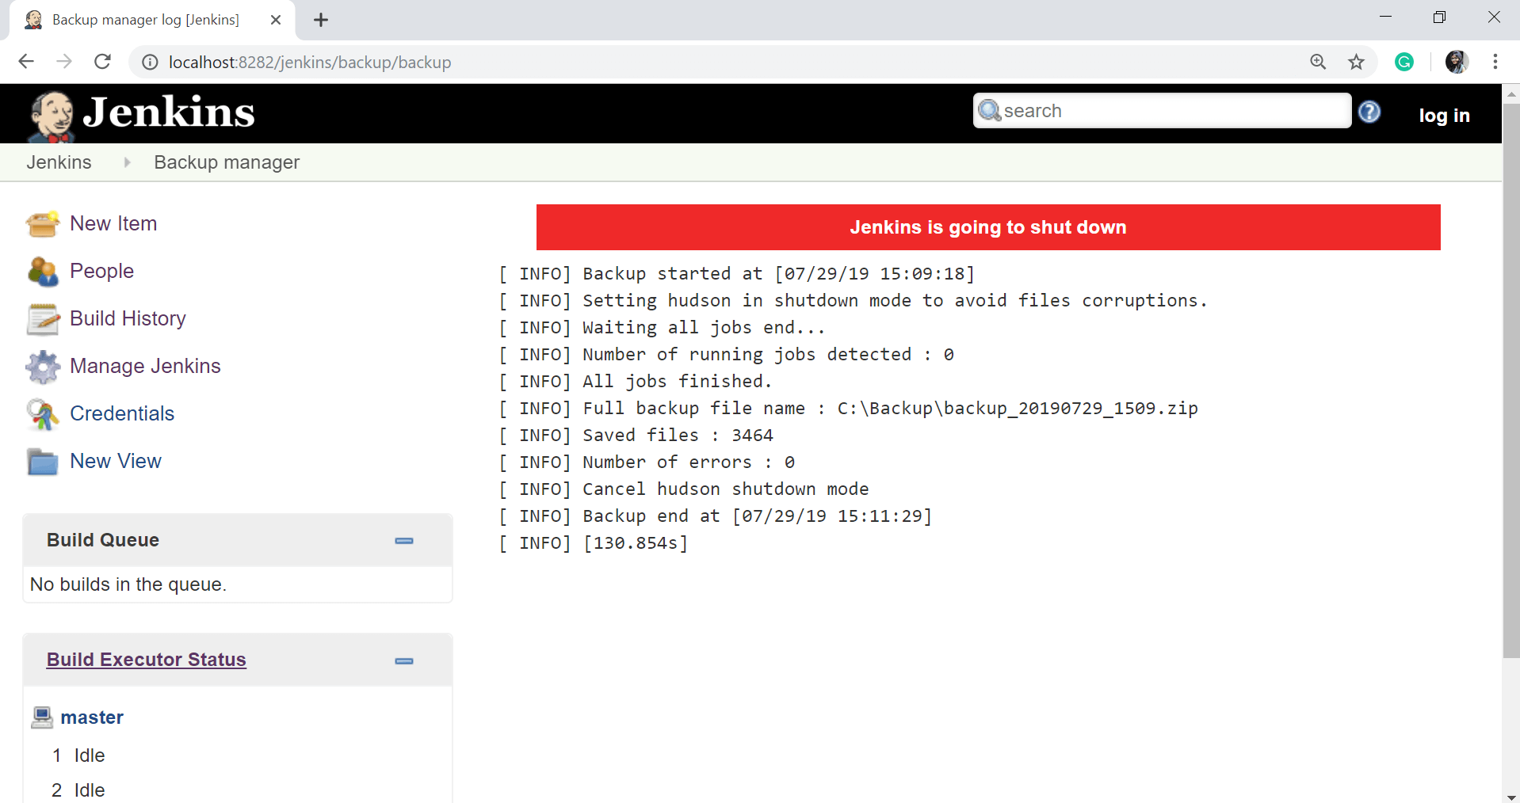

To recover from a backup, go to the **Backup manager** screen, and click on **Restore Hudson configuration**.

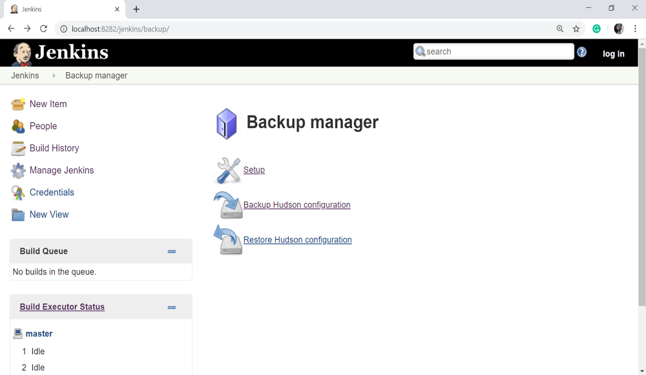

The backup list will be shown here.